**Dr Joyshankar J Jana**

**MD , DNB , FIAPM**

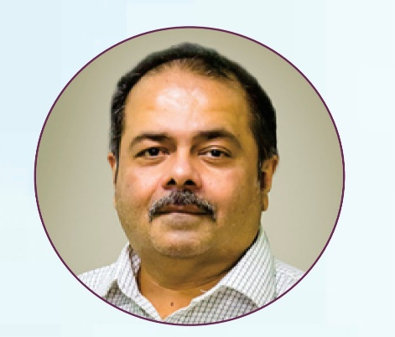

**Position** - **Senior Consultant Pain Medicine**

**Dept. of Anesthesiology & Pain Medicine , K.E.M. Hospital , Pune**

**Practice of Pain Medicine since 1996**

**Contact - Mobile – 9822034039**

[**joyshankarjana@yahoo.co.in**](mailto:joyshankarjana@yahoo.co.in)

**Awards - Best Paper presentation at ISACON 2010**

**Best Paper at MISACON 2010**

**Publications - 4 International & 2 National**

**Lectures & Workshops in many City , State , National & International Conferences & CME**

**Administrative - 1. Founder Member of Society of Study of Pain – Pune ( SSPP )**

**2. Hon. Treasurer of SSPP – 2016 – 2019**

**3. Hon. President of SSPP – 2022 – 2023**

**4. Governing Council Member ISA Maharashtra – 2012 – 2016**

**5. Governing Council Member ISA National Head Quarters – 2016 - 2019**