**CV**

**DR SANJAY KHANNA**

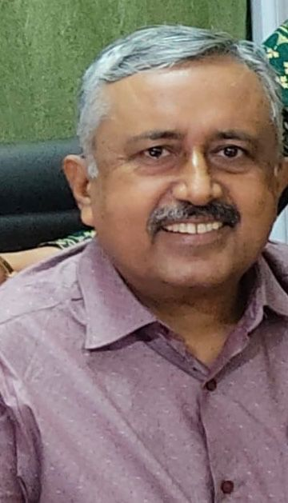

Name Dr Sanjay Khanna (MBBS,MD)

PAIN PHYSICIAN PROPRIETOR HOPE HOSPITAL JABALPUR (M.P)

Location- HOPE ICU HOSPITAL Jabalpur (MP)

MCI REGISTRATION NUMBER- 6776

Email-dr.khannajbp@gmail.com

Phone-+919826166423

**ACHIEVEMENTS**

* PAST NATIONAL VICE PRESIDENT OF ISSP.
* PAST EXECUTIVE COUNCIL MEMBER ISSP
* FIRST SINGLE SPECIALITY PAIN HOSPITAL OF WHOLE INDIA SINCE 2006.
* ORGANISING SECRETARY OF SILVER JUBILEE ISSPCON 2010 AT JABALPUR
* PAST SECRETARY MP CHAPTER OF ISSP
* PAST SECRETARY OF JABALPUR SOCIETY OF PAIN
* NATIONAL FACULTY GUEST SPEAKER SINCE LAST ¬†18YRS
* FACULTY FOR ULTRASOUND WORKSHOPS
* RUNNING TRAINNING COURSE FOR PAIN MANAGEMENT AT JABALPUR
* RUNNING 10 BEDDED PAIN HOSPITAL AT JABALPUR M.P SINCE 2006
* PAST STATE PRESIDENT OF ISA MP CHAPTER

**SPECIAL INTEREST**

1. REGENERATIVE MEDICINE.
2. NEUROPATHIC PAIN
3. CHRONIC PELVIC PAIN
4. MUSCULOSKELETAL PAIN SONOGRAPHY. (CHAIRMAN SIG MUSCULOSKELETAL GROUP)
5. EPIDURALS.
6. MIGRAINE.
7. RHEUMATOID ARTHRITES.

**EDUCATION AND QUALIFICATIONS**

* MD Government Medical College Jabalpur (MP)
* MBBS Government Medical College Jabalpur (MP)
* Senior Residency NeuroAnaesthesia (AIIMS DELHI)
* Fellowship Transforaminal Endoscopic (Maharashtra)
* Training Pain Management (AIIMS DELHI)